

QUICK SET UP GUIDE
Print Quest & Pop Quest

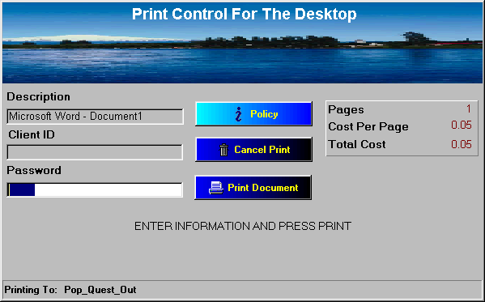

Quick Setup Guide
PrintQuest and PopQuest

The following is a setup guide for installing PrintQuest software on a release station for demonstration purposes. The hold and release printers will be installed locally on the release station with one connected workstation printing to it.

Setup begins with the creation of two (2) network printers. Create a local hold printer through the Windows Add Printer function. Point the printer to direct jobs to Lpt1. Once the printer is created right click and pause the printer. The printer must be set to print in RAW format. (Fig 1) Right click on the printer and share the printer with an appropriate name. (ex. Lab1Hold) Check the security of this printer to ensure that everyone has full control of the printer.
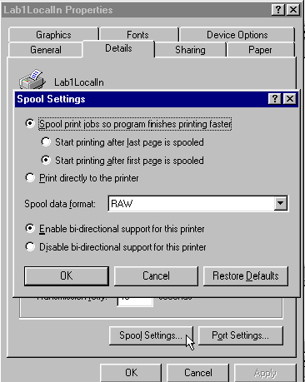
Fig 1

The second step is to create a release printer. The set up is similar to the hold printer except that it is not shared and only the release station login name has full control. It is also not paused, but is configured to print directly to the printer. It can be set up either as a local network printer or directly through a parallel cable.
The last step is the workstation setup. Create a local paused printer identical to the hold printer created on the release station, but do not enable sharing. Name the printer appropriately (ex. Lab1LocalIn). Ensure the local login user has full control permissions to this printer.

PopQuest

Install the PopQuest software on the local workstation. There are two main applications within the PopQuest software, PopQuest and DQuest. DQuest is the application to configure PopQuest to your needs. PopQuest is the actual application that is launched with the startup of the computer. Run the DQuest to configure the PopQuest environment. (Fig 2) The PopQuest will be monitoring print jobs printing to the local printer Lab1LocalIn and sending them to the network printer Lab1Hold. It is also configured to charge 5¢ per page. The local spool directory is set to C:\WINDOWS\spool\PRINTERS. This is the location of the local spooler directory.

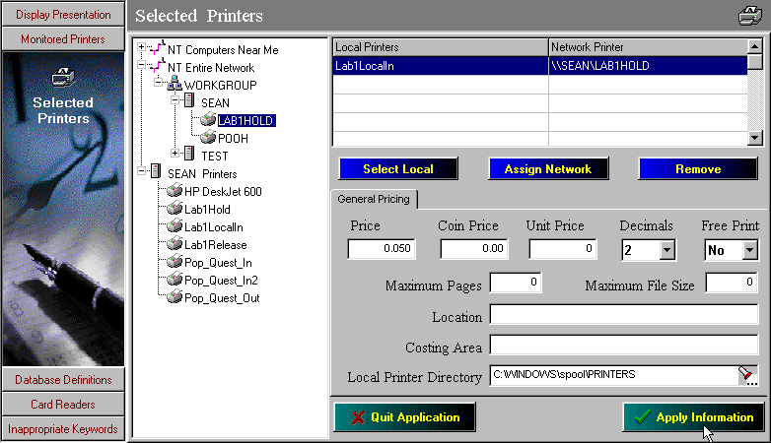
Fig 2

Ensure the “Apply Page Counts” feature is checked in the General Definitions of the Display Presentation. (Fig 3)

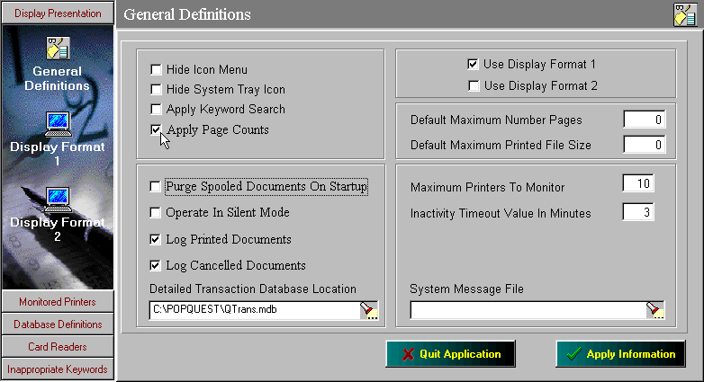
Fig 3

After PopQuest is configured launch the program by running the PopQuest.exe application. When the application is running a small desktop icon will be displayed in the system tray. (Fig 4)

Fig 4

PrintQuest

Install the PrintQuest software on the release station. The PrintQuest software has two separate applications, PQuest and PQustcfg. PQustcfg is the configuration application and PQuest is the actual application that runs during the monitoring process. Start the PQustcfg program first to configure the program. Select the Monitored Printers button to configure the application. (Fig 5)

In this example PrintQuest is configured to monitor print jobs coming into Lab1Hold and send the print job to Lab1Release. It is also configured to charge 5¢per page and delete jobs in the printer after 120 minutes. Again it is important to ensure that the proper spool file location is specified in the application.

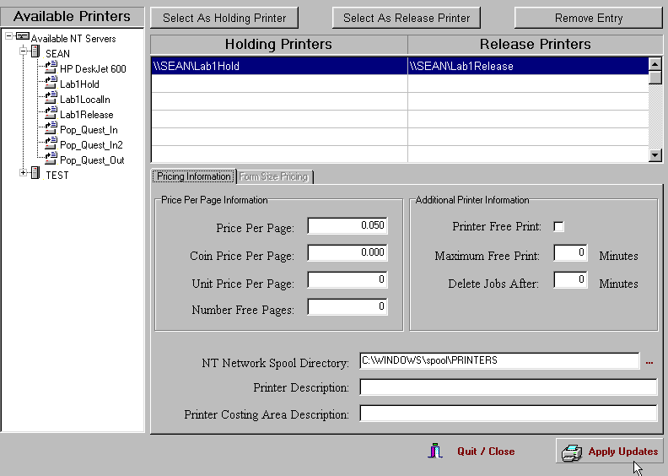
Fig 5

If a payment device such as a card reader is going to be used select it from the card reader list under Payment Methods. Select the com port to be used and then start the PQuest application. If the application is not configured to launch immediately then press the Activate button to launch the monitor. The monitoring screen will be displayed similar to Fig 6.


Fig 6

The print monitor list can be enabled by either inserting a card or by pressing the big button on the screen. Once the list is displayed the user simply selects the job(s) they wish to print. The funds are deducted and the print job is released to the printer.

Important Notes

- To exit the print monitor screen press Ctrl-Alt-E. A username/password screen will appear and enter the following:

Username: iteam
Password: iteam

- In order for the PopQuest and PQuest programs to start automatically the program executables must be inserted in the startup of the PC’S.

- To turn on the page counter on the release station the following registry key must be changed:

HKEY_Local_Machine → Software → PrintQuest → SystemValues

In the system values there is key called RequireLocalPageCounting. The default value for this key is 0. To change this key simply right-click on the key and select modify. Change the value from 0 to 1 and the page counting will be enabled.

For any further information please refer to the individual product manuals, or call iTeam Resources at 678-261-4002 and select the option for technical support.

If WinNT or 2000 is used as the operating system ensure that “log spooler warning events” is off

