

CheckPASS Print Management software

Description

Software program designed to manage, control, and recover stand-alone or network printing costs in a pay for use or account balance environment.

CheckPASS includes 2 distinct modules, PrintQuest and PopQuest, and operates in the following environments:
- Stand-alone
- Peer-to-peer network
- Local building server network (operates on all platforms i.e., Citrix, NT, Novell, Windows 2000)
- Central campus server network (LAN/WAN all platforms)

PrintQuest

Description

Software is installed on a dedicated print release station PC to allow users to pay for print from a centrally located station using coin, bill, and/or card or declining account balance. The release station PC can also act at the print server where required. The release station monitors print jobs, calculates number of pages and job cost.
Pictures


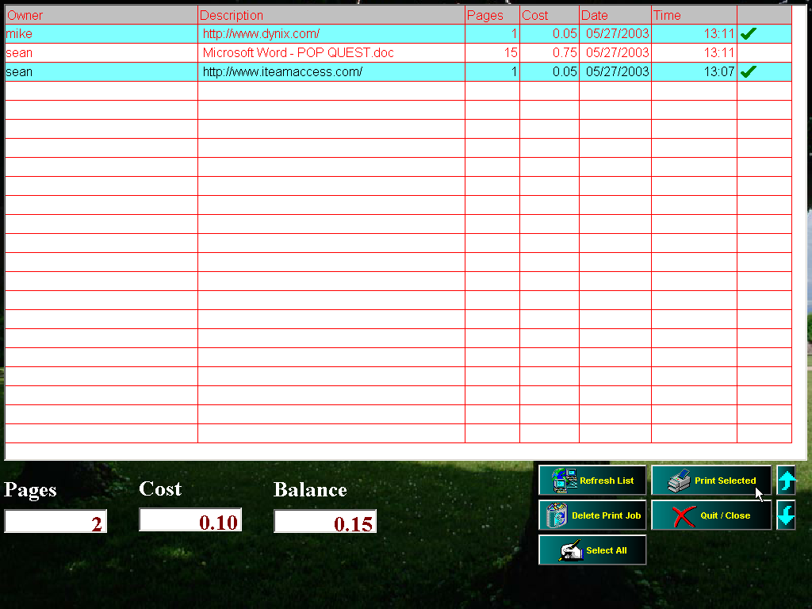

PopQuest

Description

Software is installed on each patron/client workstation. The software monitors print jobs, calculates number of pages in print job, print job cost, and can be linked to the patron database. Free print accounts can be set up by patron and be automatically renewed daily, weekly, monthly or quarterly.

Pictures

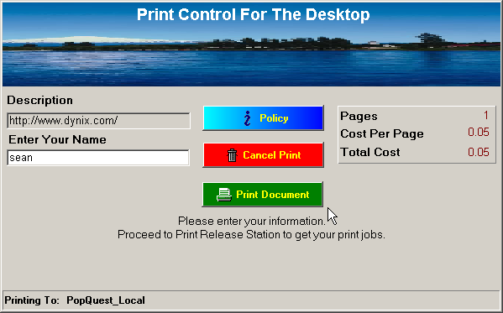

AccountQuest

Description

A cash balance is retained on a database and used by the CheckPASS product to pay for print. Databases include Quest database (uses DSN database drivers or ODBC), Novell online balances, MySQL database (ODBC), Oracle database (ODBC) and PCounter Database with more being added.

Picture

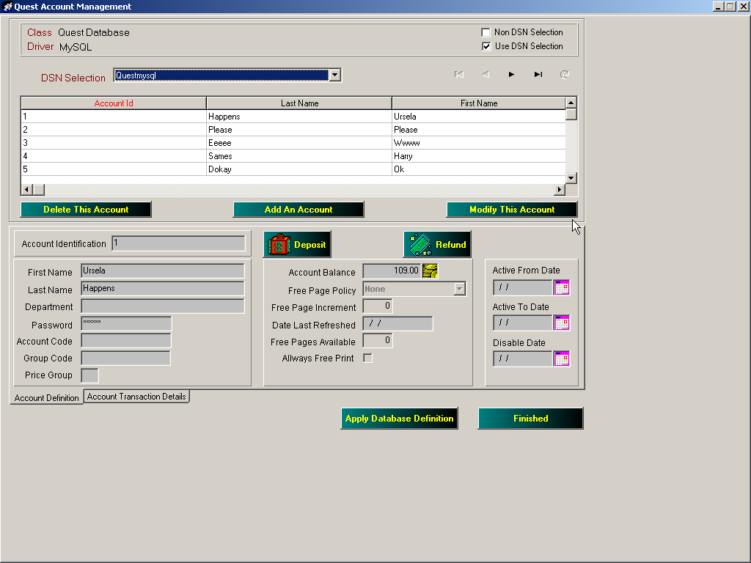

Quest Replenishment

Description

This software module allows a patron to replenish their online account balance or debit card. It is installed on a dedicated PC with a payment tower (coin, bill, and/or card vend station) serially attached.

Pictures

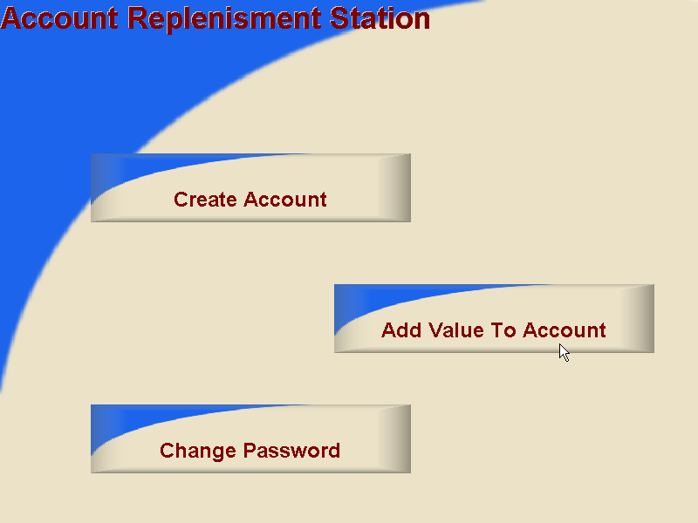

ReportQuest

Description

Software module designed to provide customers with an easy way of creating and viewing transaction history of the print management system. Reports can be generated on some of the following parameters;
  - print job owner
  - printer
  - release station
  - time/date
  - account activity, plus much more

Pictures

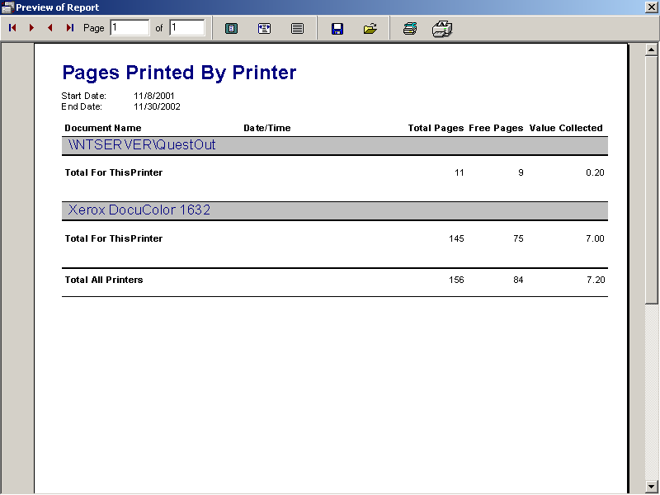

Re’Quest PC Reservation

Description

PC Reservation products are designed especially for libraries to help libraries manage their public access computers, and includes:
  - Time Control – ability to automate the total amount of daily time users have on the library’s public access computers.
  - Patron Authentication – provides unique patron identification, and seamlessly integrates with all major integrated library systems.
  - Security – a built-in security layer that resides between the user interface and the computer operating system to guard against saving files to unapproved disk drives, running unapproved applications, and more.
  - Reporting – powerful and flexible tool for statistical reporting on computer usage, patron usage, and application usage.

Pictures

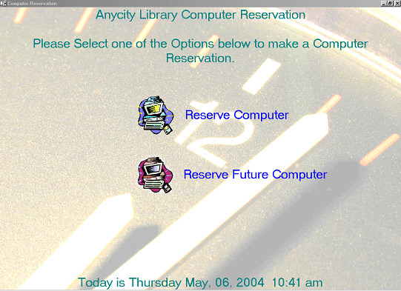

Coinop Devices (Coin/Bill/Card)

Description

This coinop device can be attached to either a photocopier, or to a print release station. Can be configured to accept coin or bill only, or have a built-in card reader.
- Accepts $ 1, $ 2, $ 5, $ 10, $ 20 bills
(Including new type bills).
- Accepts $ 0.5, $ 0.10, $ 0.25 & $1.00 coins.
- Escrows money for multiple copies.
- Provides change and refunds escrow funds not used.
- Serial interface available for print management software

Pictures

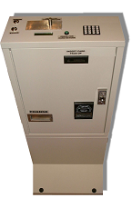

Cash Card Readers (Magnetic, Smart and Online)

Description

Options range from a basic cost recovery system to a complete cash card or online account balance system designed to be totally self-serve and nearly cash-free. Includes serial readers, copier readers, mini-tills and much more.

Pictures

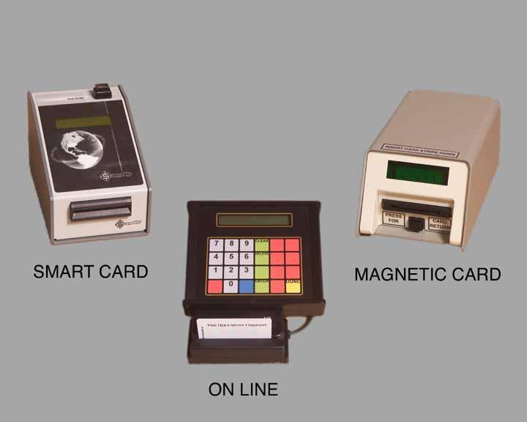

- Product Name

Card Re-valuator and Dispensers

Description

These units are designed to easily dispense cards and add value to them. The units come with an optional stand, or can be mounted to a wall. The units can be programmed to accept or deny any of the different values of currency.

Pictures
.

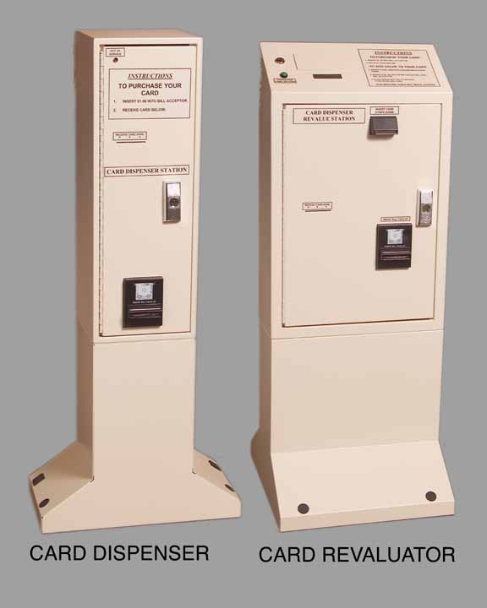

Photo-Id

Description

A variety of photo-id systems are available to meet your institutions needs including color photo’s, barcodes, magnetic and smart card technology, ODBC database connections etc. A range of cameras and printers are also available.

Pictures

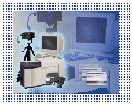

Library Combo-Cards

Description

iTeam specializes in producing custom cards to fit your institution’s needs. We provide library cards and key tags, Combo Cards- cards that act as your library card as well as patron service cards and may be used to check out books, pay for fees and fines, photo copies, Pay for Print, PC reservation and much more. We also offer a Photo Id . All cards are available with custom artwork and design.
Pictures

